**Name: Yash Jain**

**B.Tech(Hon)-CSE- II yr**

**DBMS Lab Assignment 1**

**Creation of Tables:**

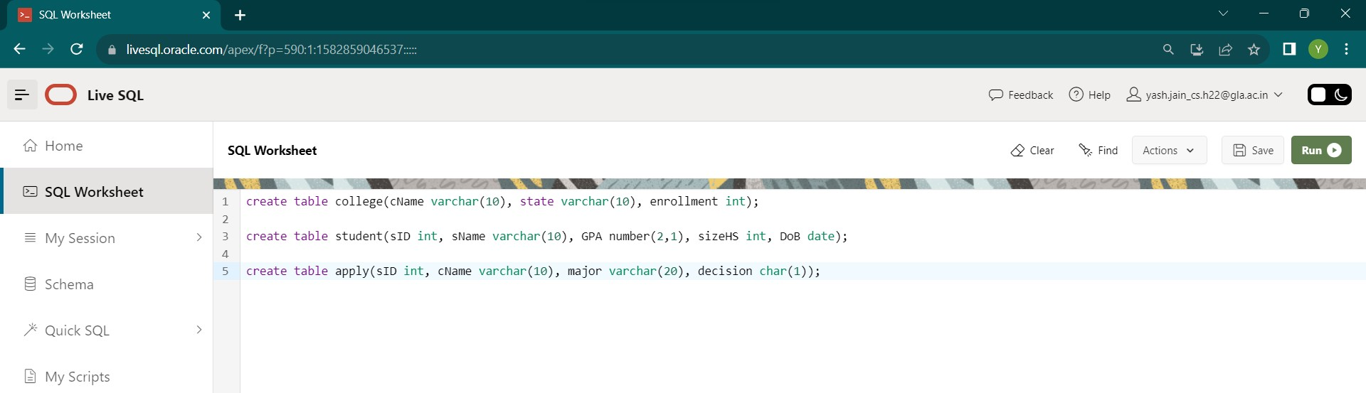

**Insertion of values:**

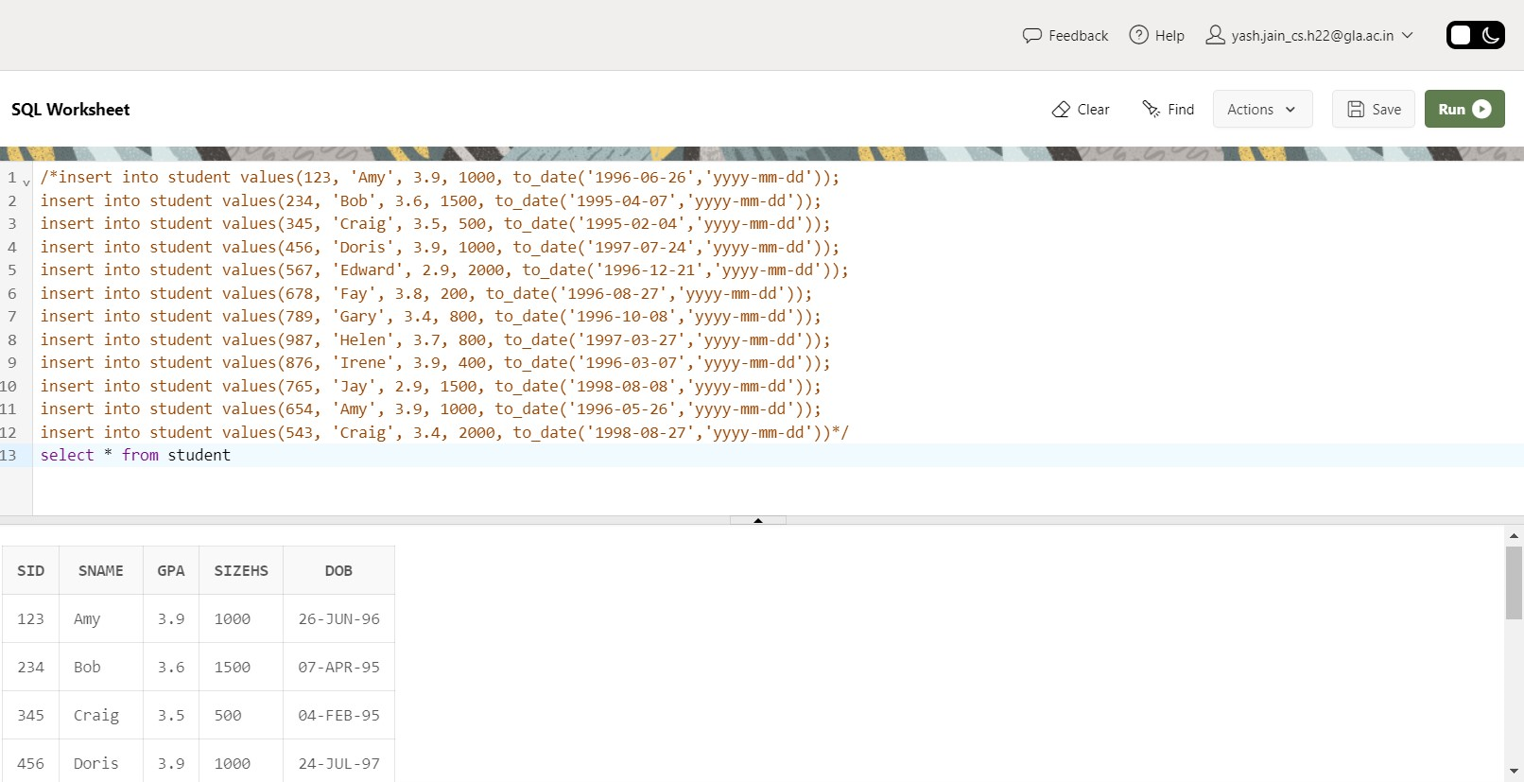

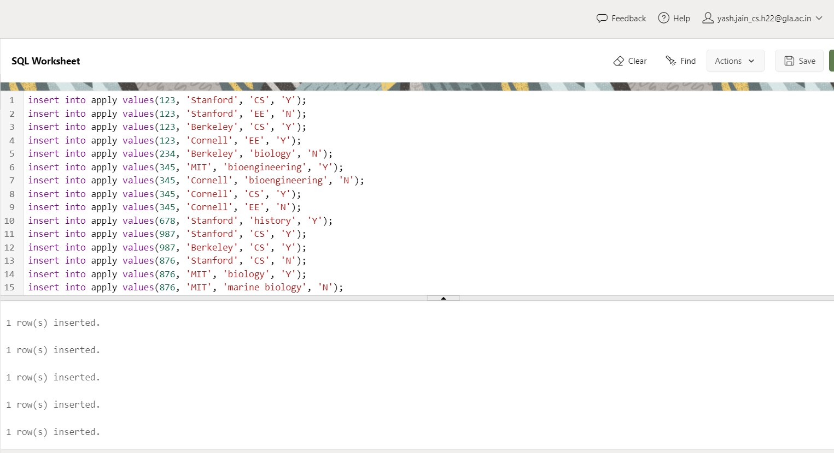

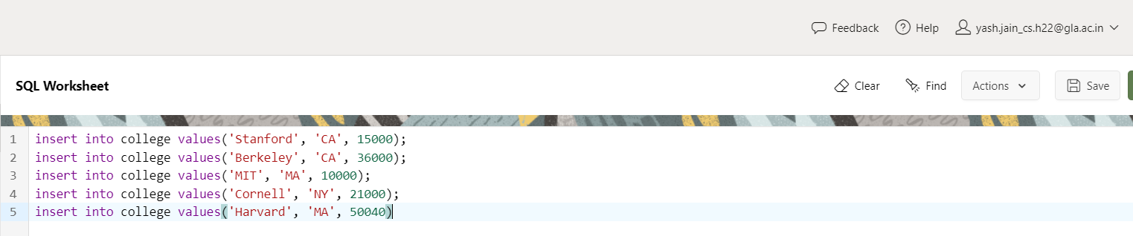

1. List the student name, dob from student table

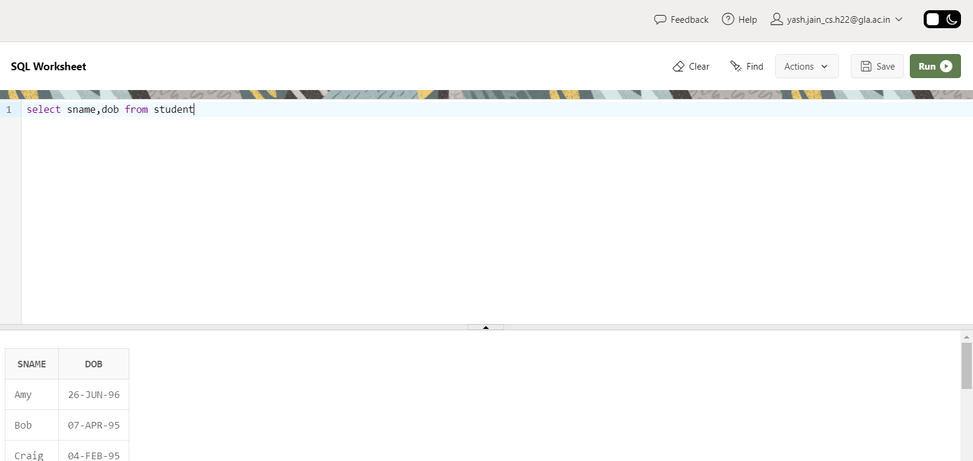

1. List the name of student scoring more than 3.7 in GPA.

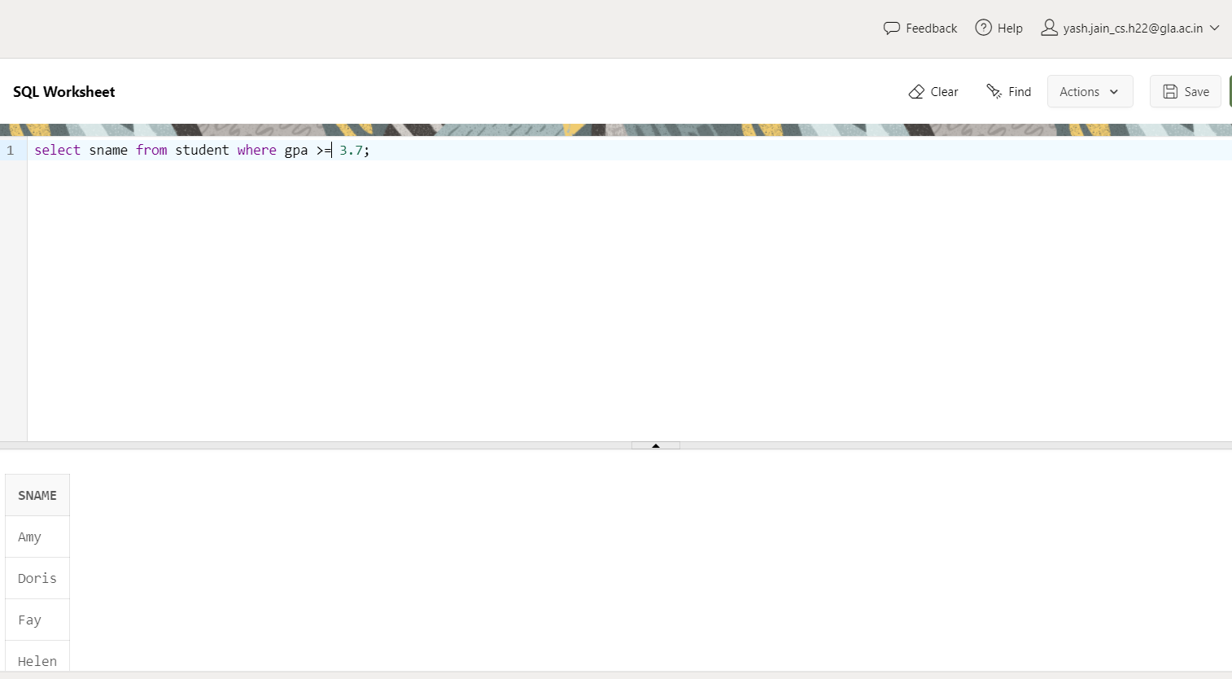

1. List the name of student whose High School size is at least 1000 and born after 1996. [Hint: check DoB greater than 31st December, 1996]

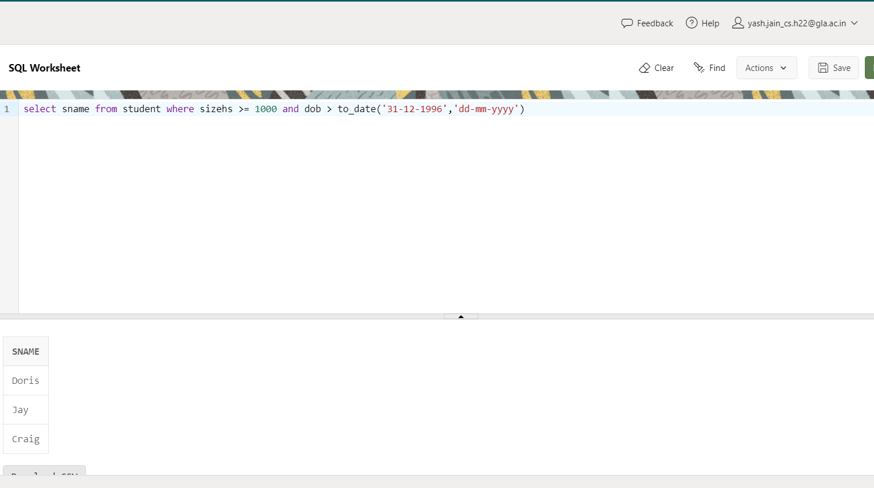

1. List the name of student who are scoring GPA in between 2.9 and 3.9

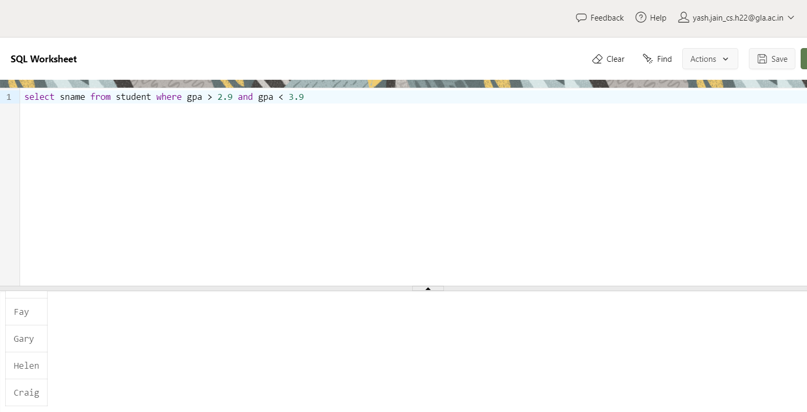

1. List all the details of colleges who situated in MA.

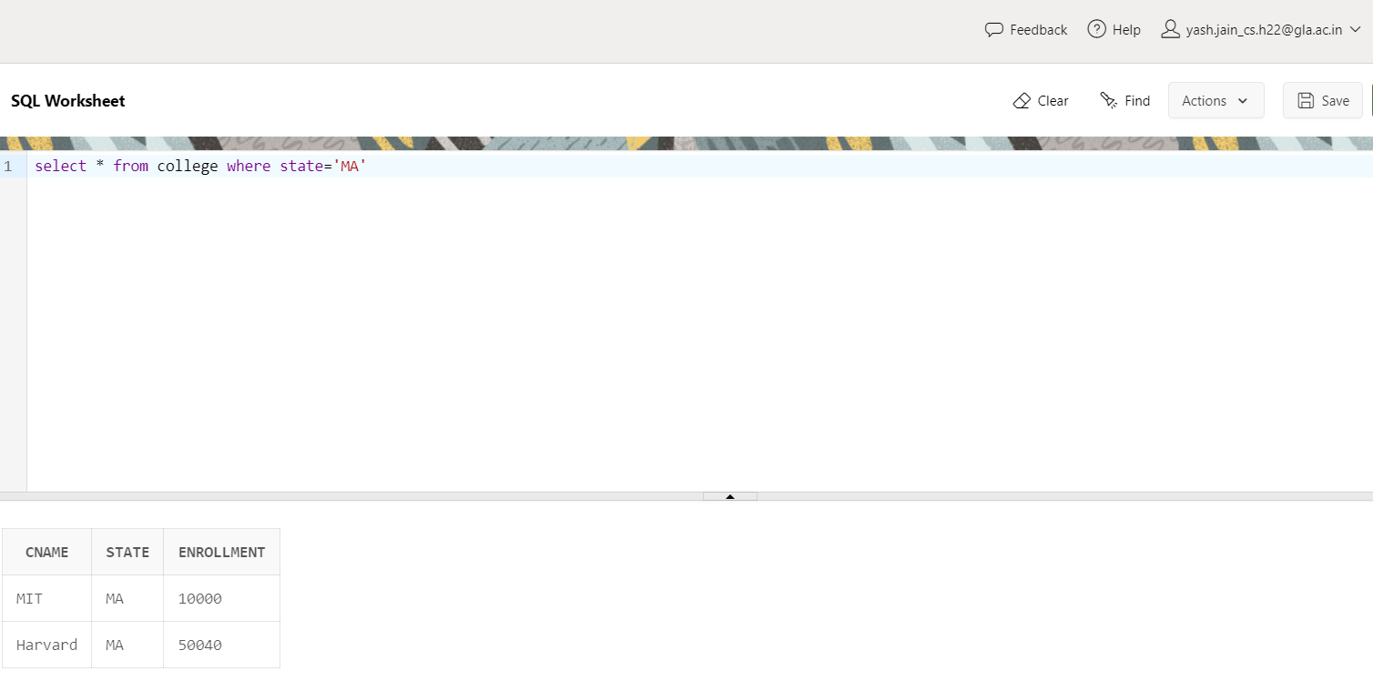

1. List the students who are scored more than 2.0 but less than 3.5

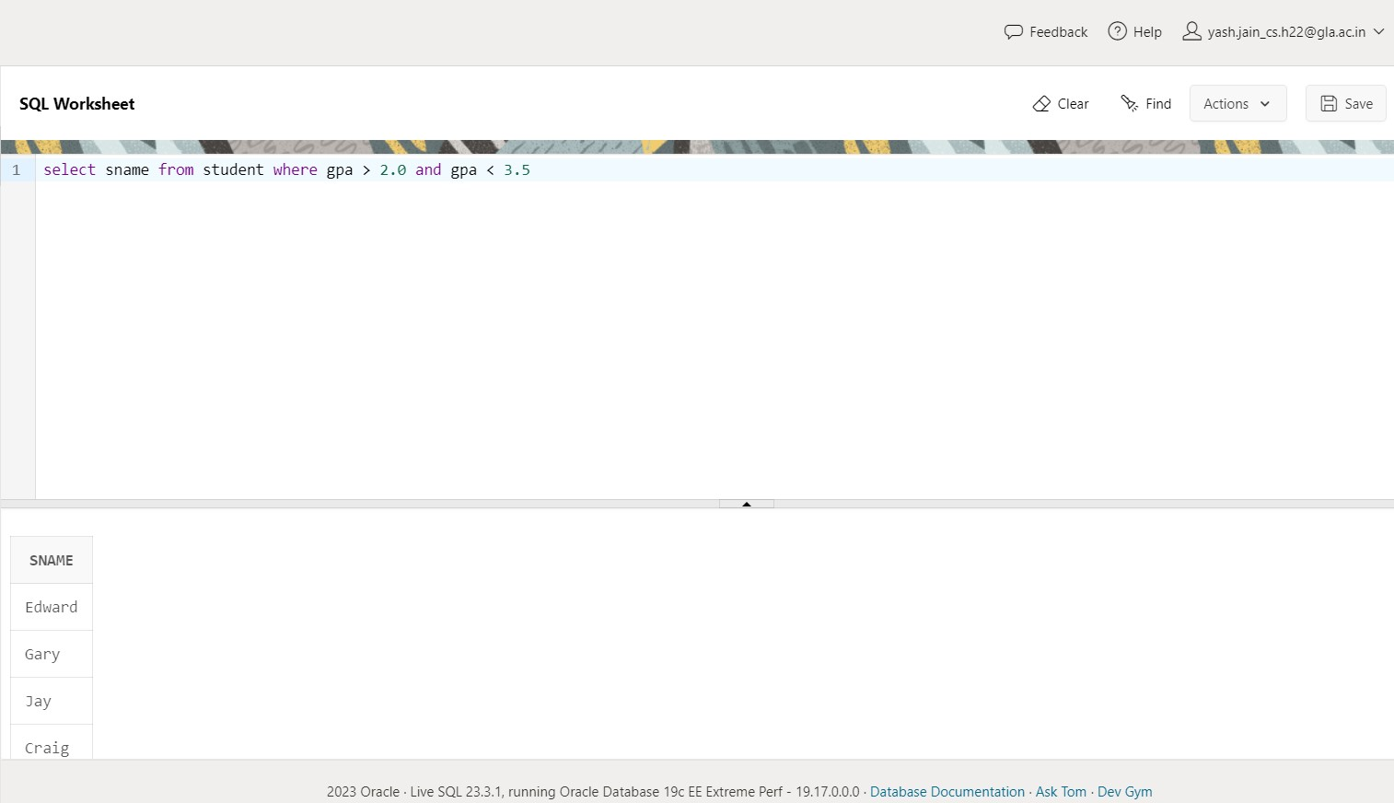

1. List the students who have born after 1st Jul 96 in the order of the Date of Birth

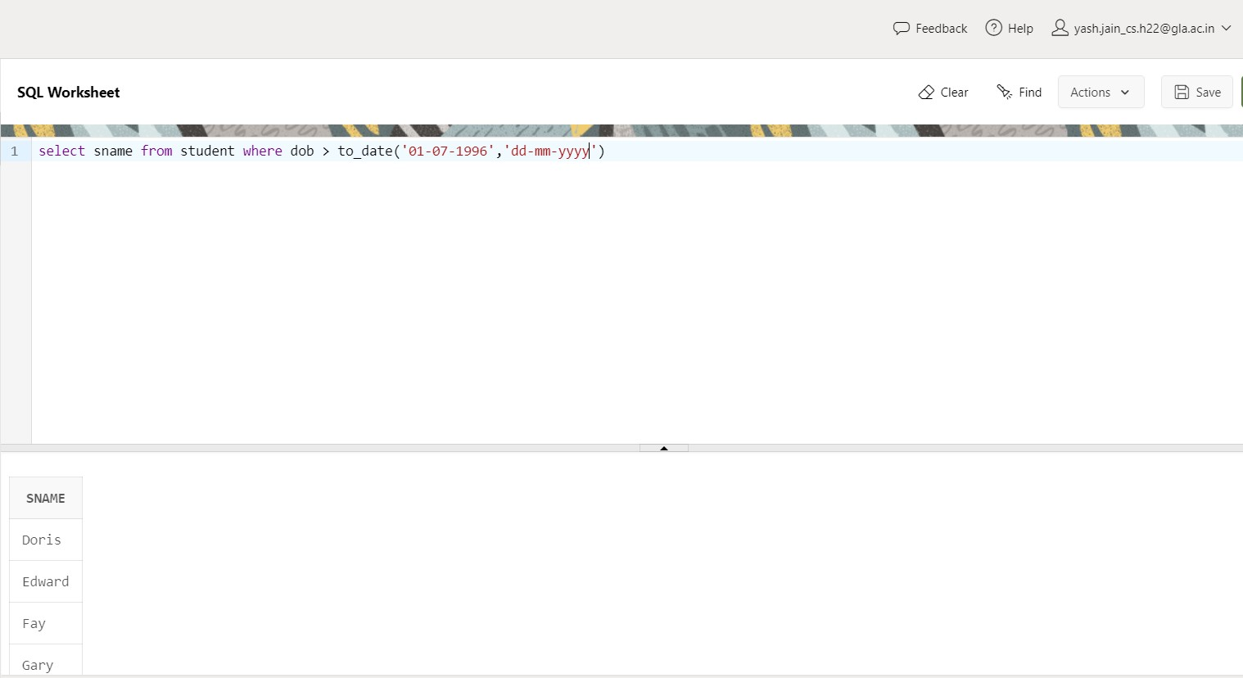

1. List the sID, cName, decision of applications that are accepted.

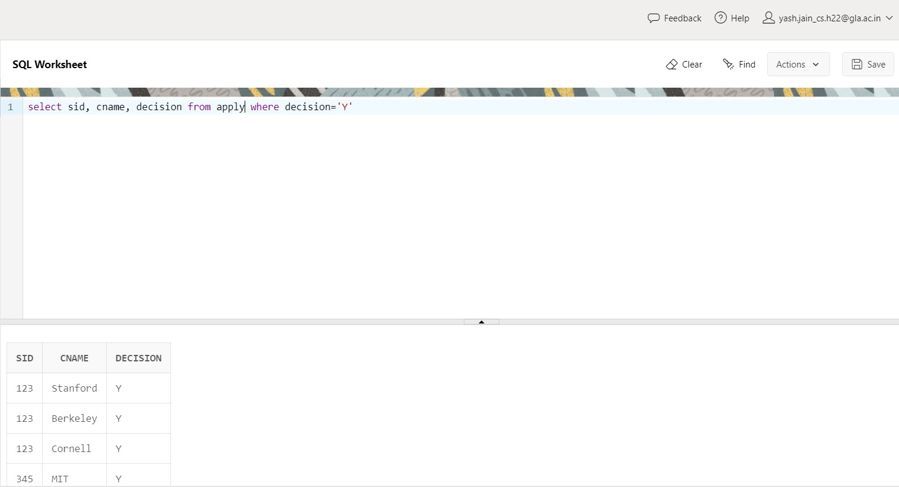

1. List the sID, cName of applications which are filled at Stanford.

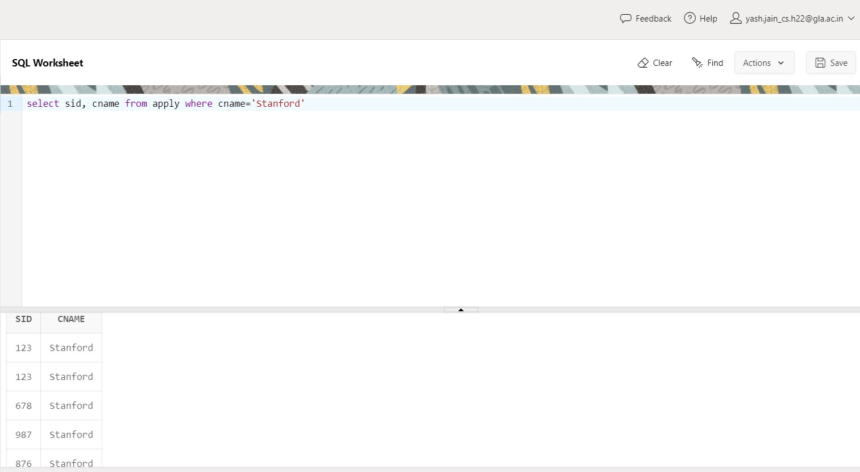

1. List the colleges that that has enrollment greater than 10001.

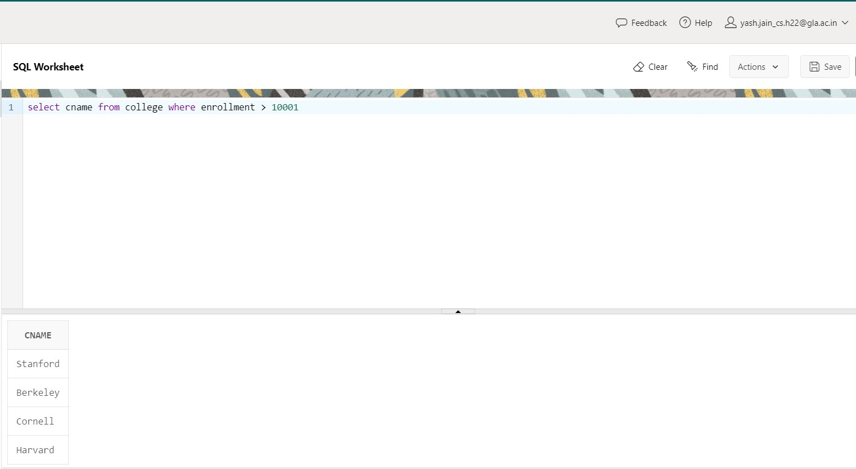

1. List the colleges not in California.

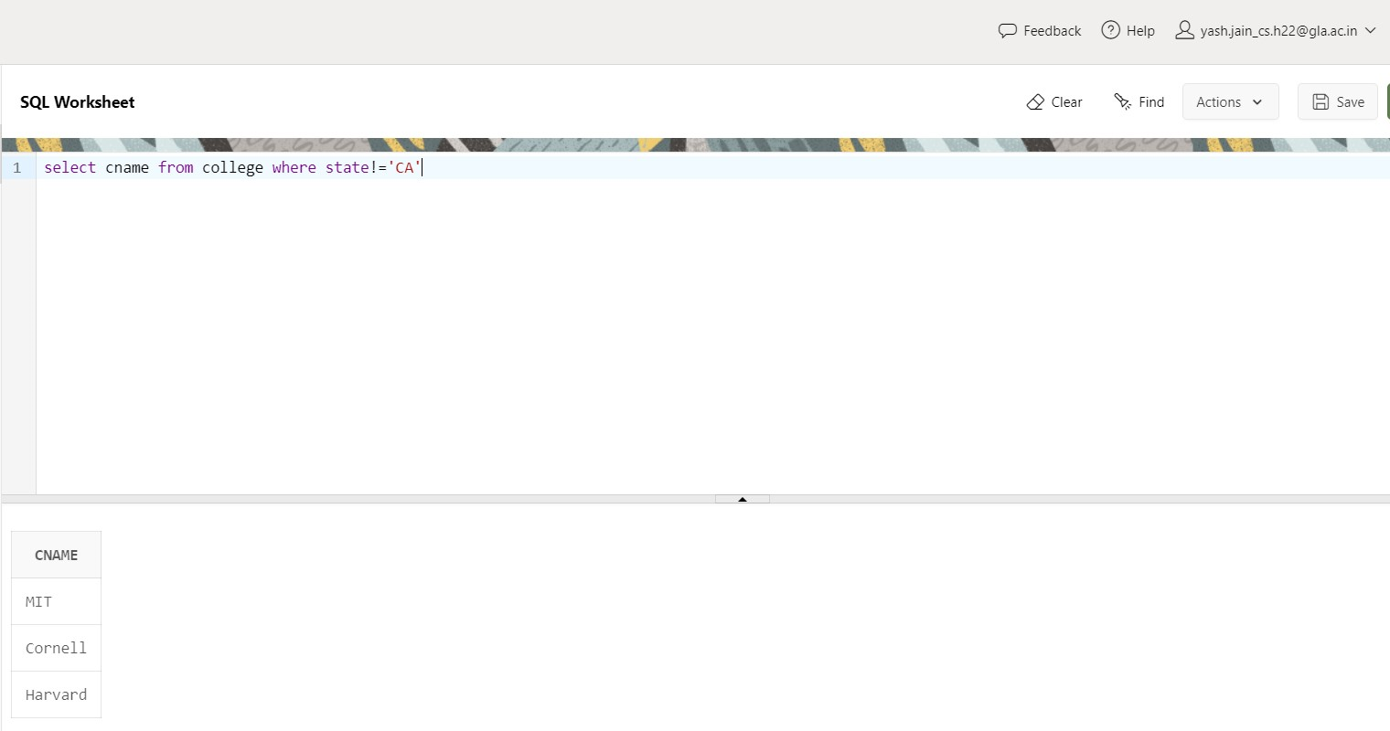

1. List names of all student who came from high school having size greater than 17000 and scored GPA less than 3.8.

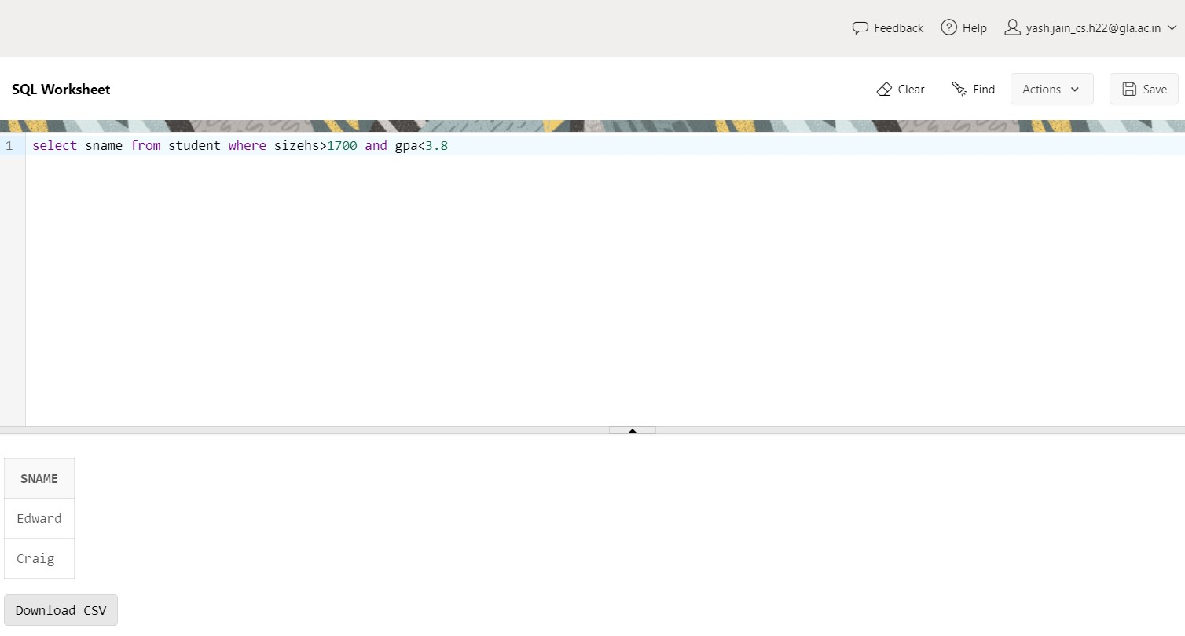

1. Display the description of the Student table.

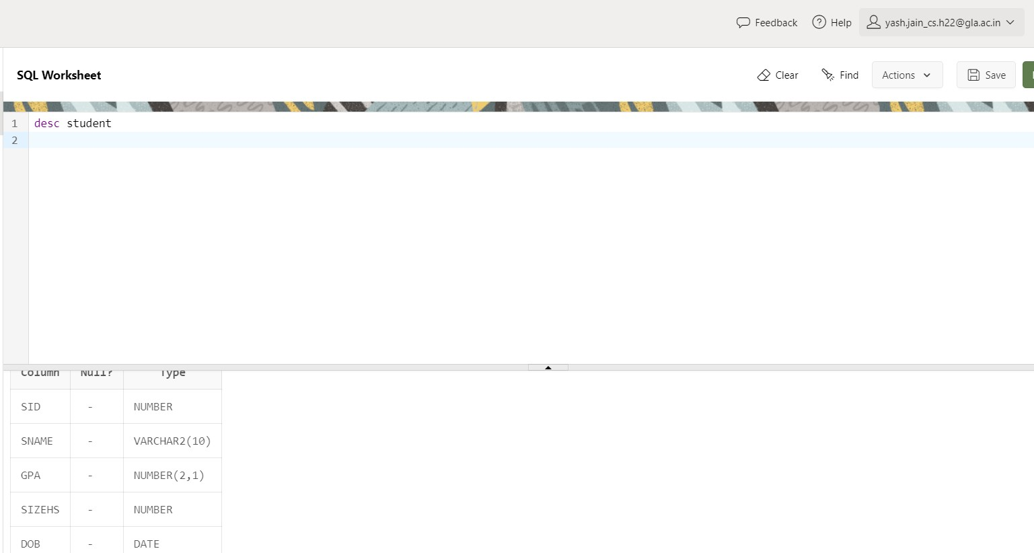

1. Display the details of all students.

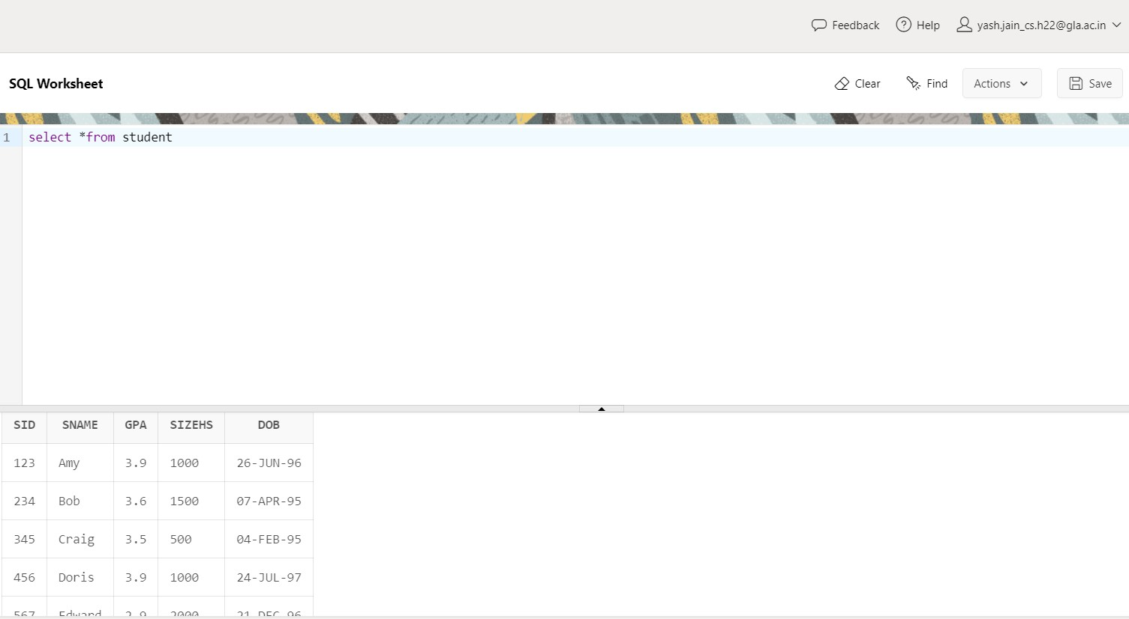

1. Display unique majors

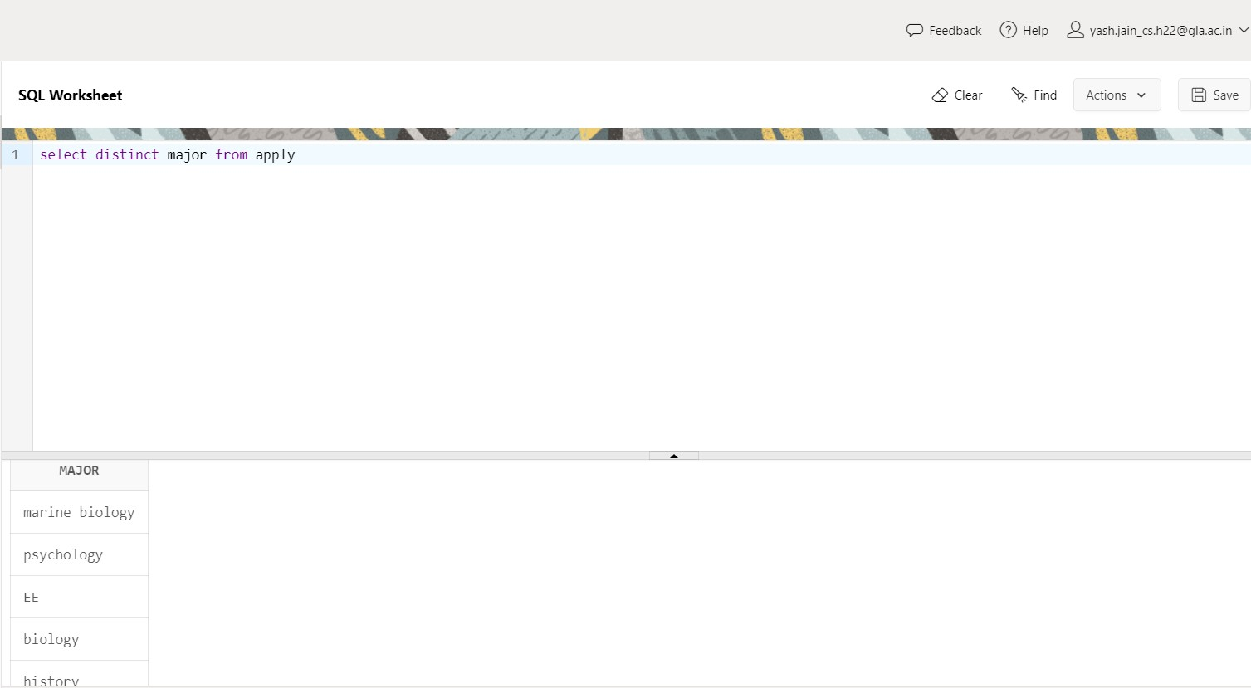

1. List the student names those are having three characters in their Names.

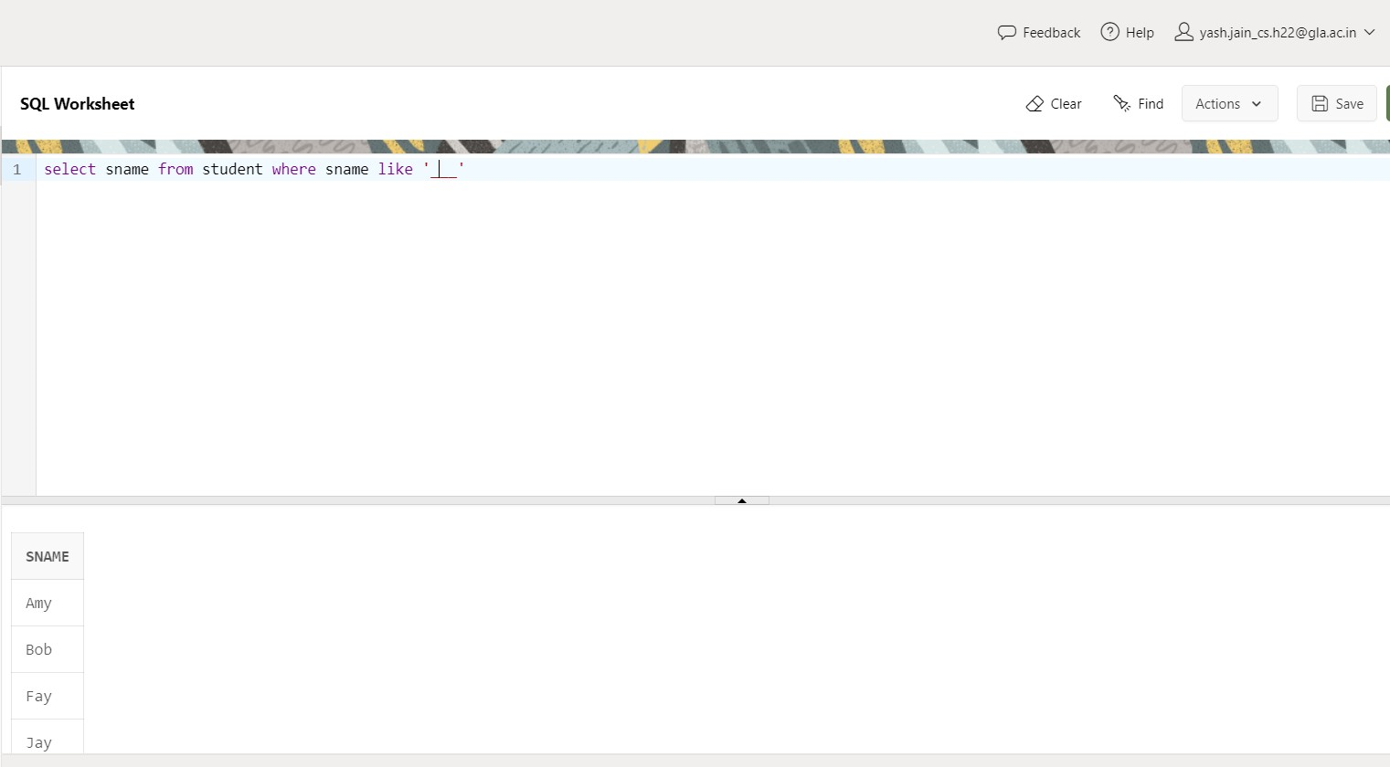

1. List the student names those are starting with ‘H’ and with five characters.

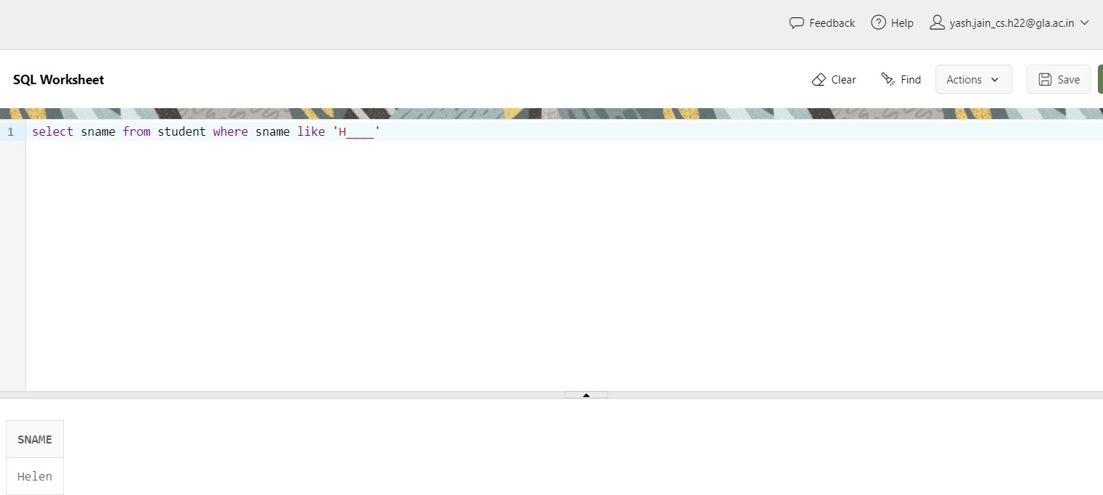

1. List the student names those are having third character and fifth char. must be ‘e’.

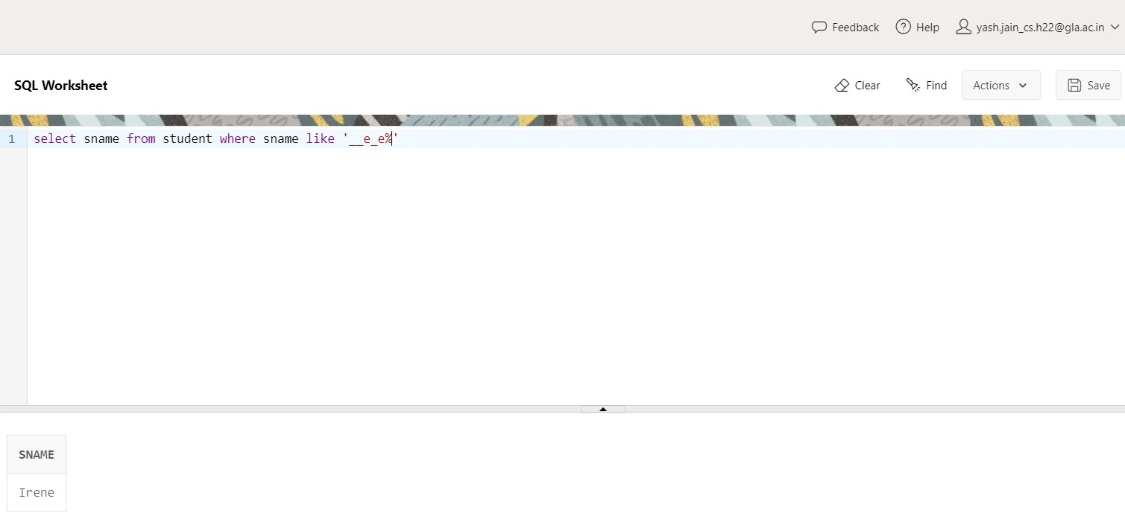

1. List the student names ending with ‘y’.

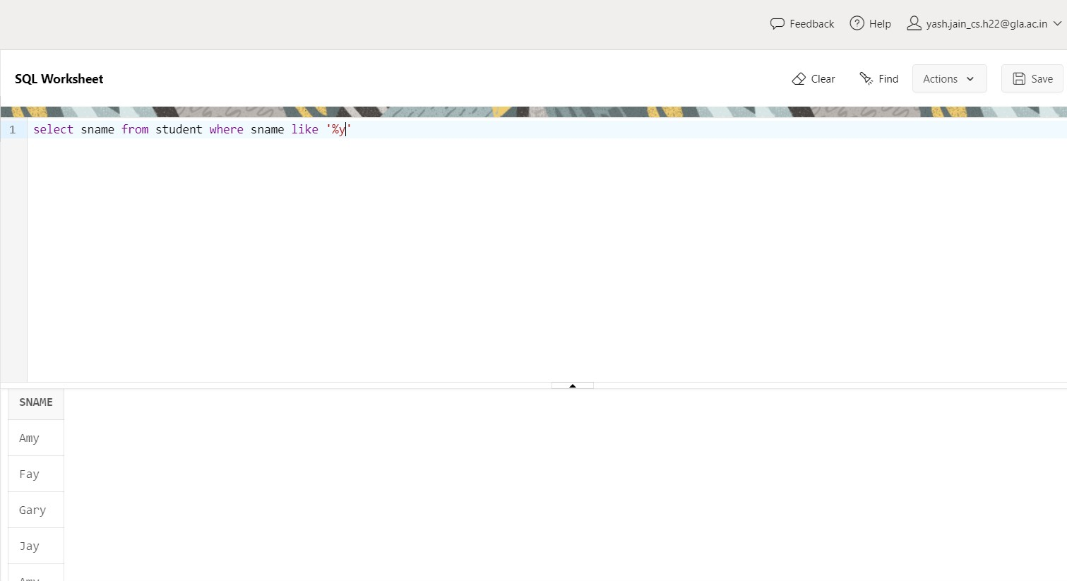

1. List the Students in the order of their GPA.

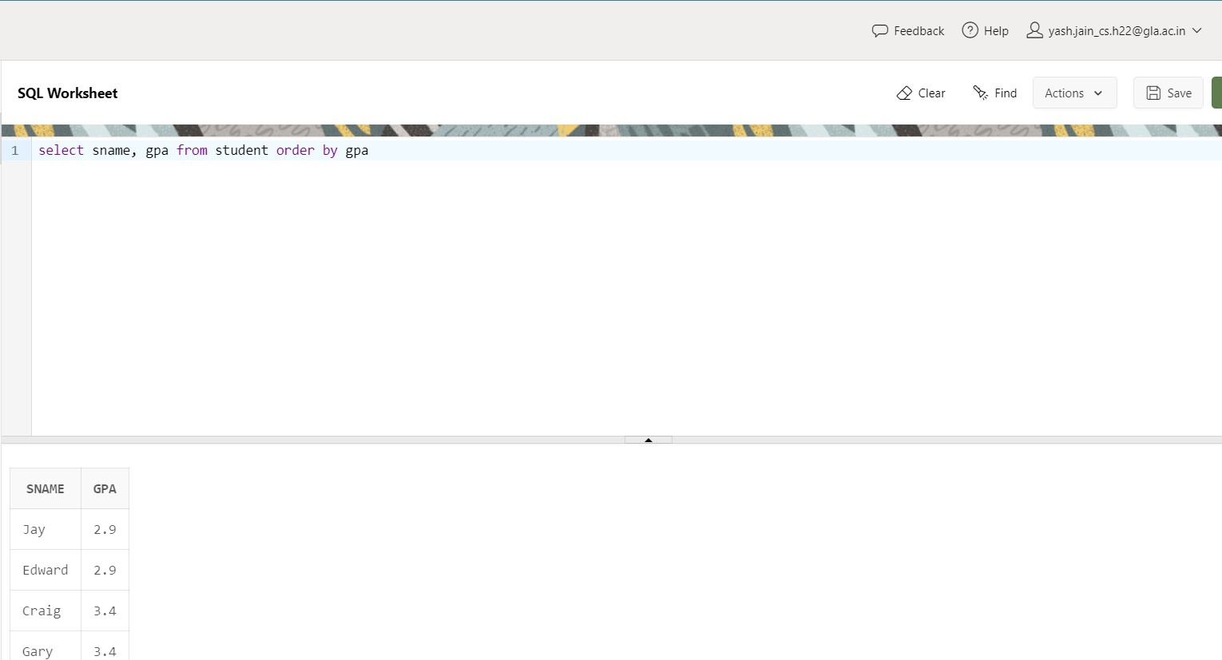

1. List the details of the students in order of the ascending of GPA and descending of DoB

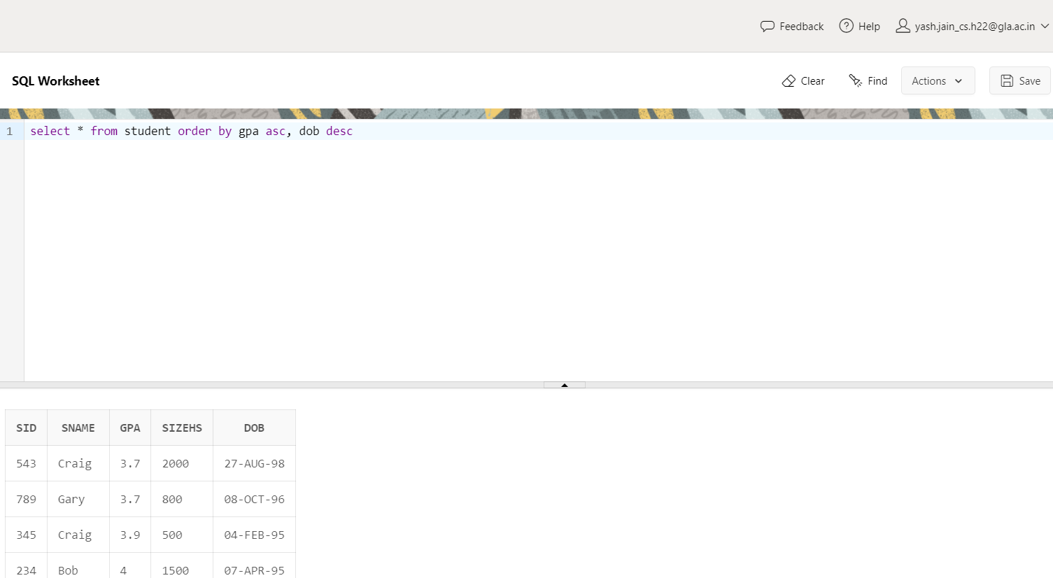

1. List the sIDs of student who apply in either ‘Stanford’, ‘Cornell’ or ‘MIT’ college

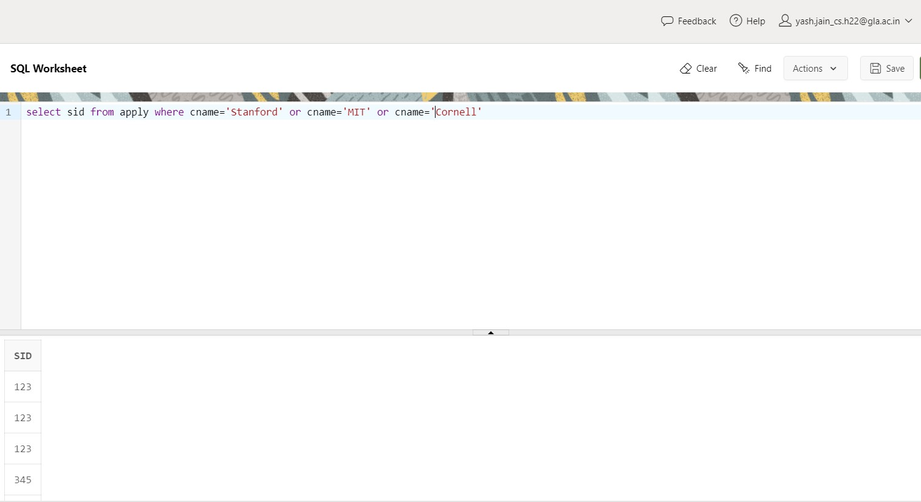

1. Delete all applications filled at Stanford (Choose table wisely)

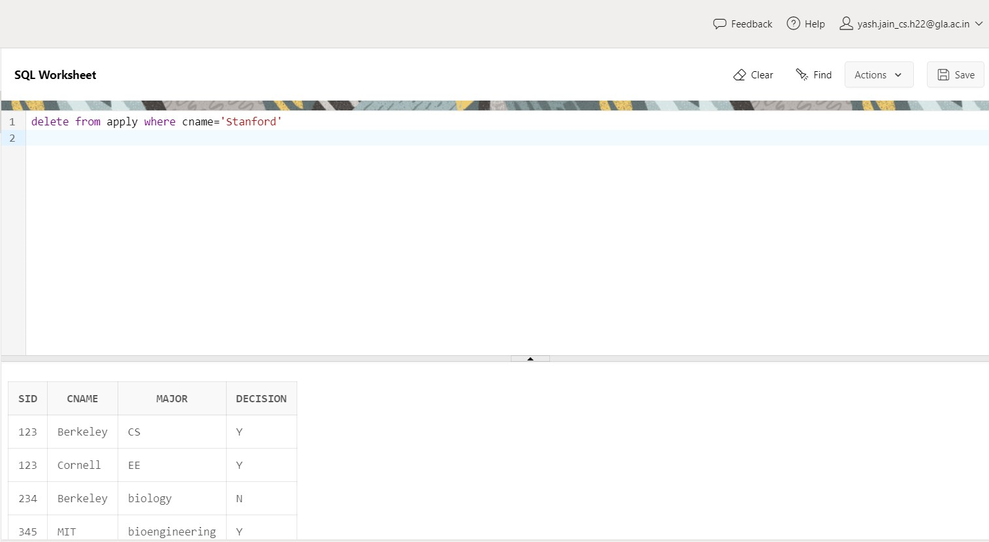

1. Delete the college Stanford from college table.

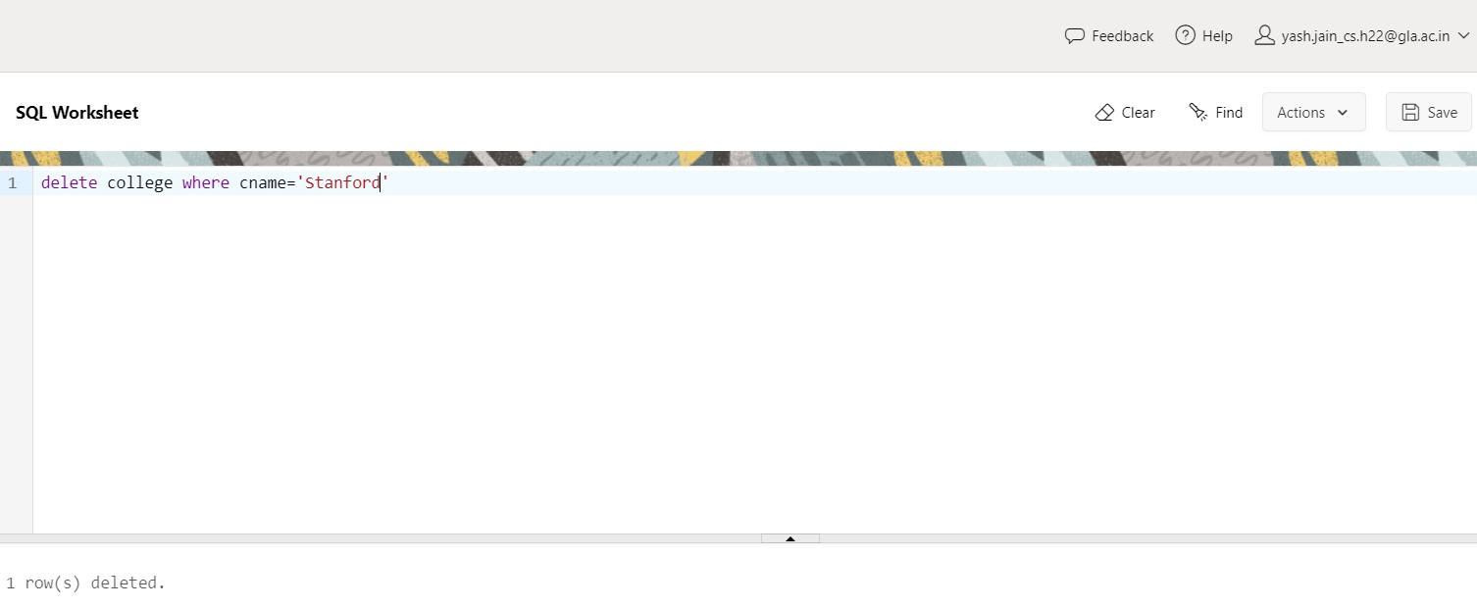

1. Modify the GPA of all students by giving 10% raise in their GPA.

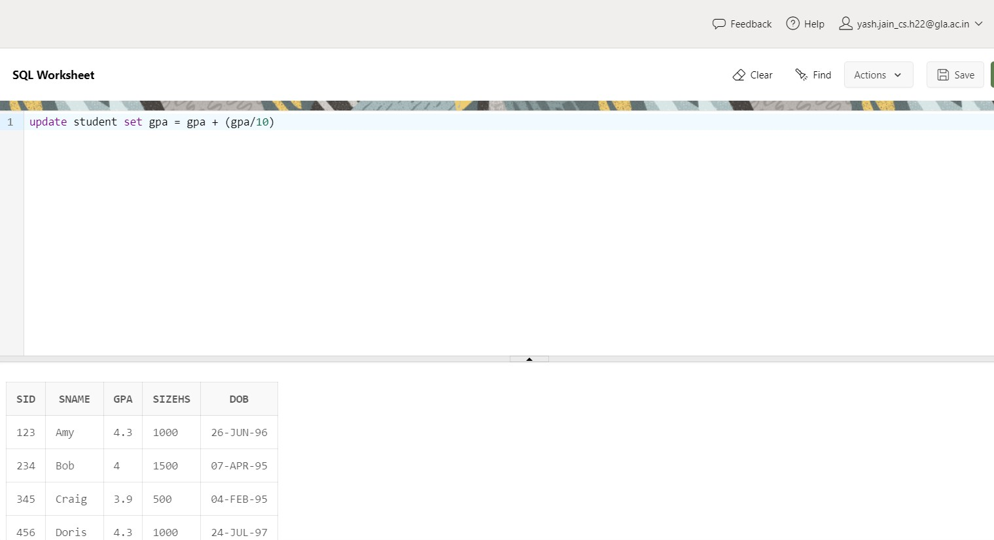

1. Increment the GPA of the students by 1.5 whose GPA is less than 3.5 and belongs to High School having size greater than 1500.

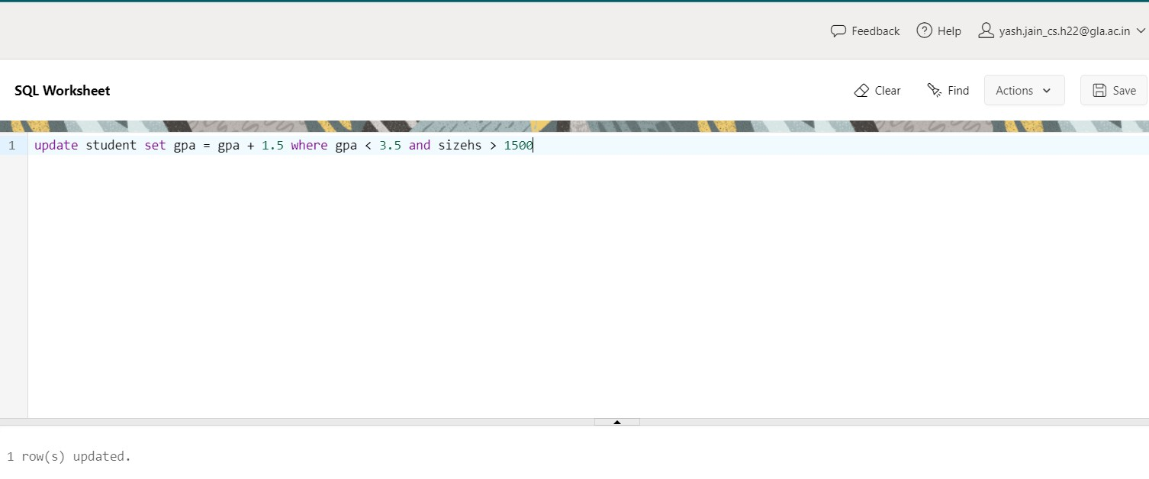

1. Delete the students who have scored less than 3.2 GPA.

